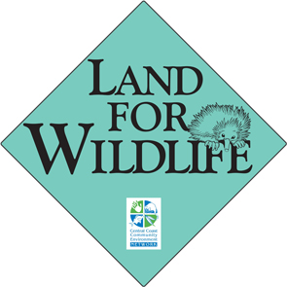

LAND FOR WILDLIFE
LANDHOLDER EXPRESSION OF INTEREST FORM

- ESSENTIAL CONTACT DETAILS

Owners Names

Owners Names | Please indicate or include name of contact person/s
Property Name & Address

Postal Address
(if different)
or extra phone Nº.s
Telephone | (H) | FAX
Telephone | (W) | E-mail
Telephone | (mob) | E-mail
Site visit | - Yes, I am interested in receiving free on site advice on managing part of my land as habitat for native plants and animals.
Mail list | - Yes, I would like to be informed of workshops, property open days and other project events, by: post / email only / either (please circle one)  - Yes, I would like to be included on the mail list for CEN newsletters and other information.

B. OTHER PROPERTY DETAILS Not essential - These details help us prepare for your site visit.

Lot and DP  (If available)) | Lot or Portion Nº. | D.P. Number | Parish and County (if known)

The Lot and DP enable us to prepare a base map and vegetation community map to bring to the site visit.

Area of property | ha | Area of property with native vegetation | ha
(1 acre = 0.405ha, 1ha = 10 000m²) (including areas of trees, native grassland etc.)

Local council area | □ Byron □ Tweed  □ Ballina | Subcatchment  eg Mullum Ck, Wilsons Ck
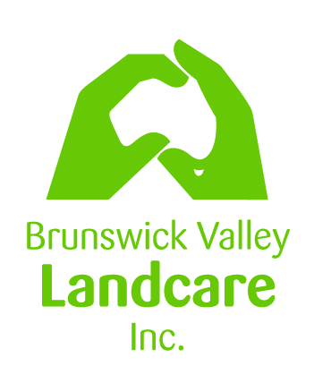
N.B. Involvement in the Conservation on Private Lands Project does not change the legal status of your property. The information you provide will be used in accordance with the Privacy & Protection of Personal Information Act 1998. All information that is collected can & will only be used for project administration. It cannot be given to any other party without your permission. If you are concerned about how this information may be used we will be happy to discuss it with you.
Please complete the other side…
Return form to: PO Box 6, Brunswick Heads NSW 2483
Email: alison.ratcliffe@byron.nsw.gov.au Phone: 02 6626 7028
C. YOUR INTERESTS Not essential - These details help us prepare for your site visit..
The Land for Wildlife program aims to help landholders look after natural vegetation on their lands. Participation in this project is entirely voluntary. We can assist you by visiting your property, giving you advice on the natural values of your property and how you can manage the natural areas on your land. We can also provide you with advice on incentive programs designed to help landholders and protect vegetation. Other opportunities include workshops, training, networking with other landholders, help with plants, bush regeneration (depending on availability) and advice / help regarding funding opportunities.

1. Conservation  Incentives | Are you aware of conservation incentive programs for private landholders? YES / NO  Are you interested in conservation incentive programs? YES / NO  Are you currently involved in a conservation incentive program? YES / NO
1. Conservation  Incentives | If yes, which one/s?
2. Reason for  Interest: | I would like advice on: (please tick)  - Weed control / weed management  - Weed identification  - Native plant identification  - Providing habitat for wildlife |  | - Habitat assessment of my property  - Seed collection and propagation  - Supply of locally native plants  - Property management advice  - Other _________________________________________________
2. Reason for  Interest: | What are the main values of your land to you? _______________________________________________________________________  _______________________________________________________________________________________________________________________________________________  Why do you think your land is valuable as wildlife habitat? _____________________________  ______________________________________________________________________________
5. Property Sketch  Draw a sketch of your property showing:  •major roads  •boundaries  /fencing  •buildings / house •major landuse  (cropping, grazing  etc)  •areas you to  replant/regenerate •corridors /  proposed corridor  •stock watering  points  •areas of native  vegetation to  protect/restore | N..
If there is any additional information you would like to provide on your land or why you are interested in the program you may attach a separate sheet.
Return form to: PO Box 6, Brunswick Heads NSW 2483
Email: alison.ratcliffe@byron.nsw.gov.au Phone: 02 6626 7028

